How to: Dataset Preparation
This document provides step by step details on how you can prepare your dataset for Batch Testing.
Prepared by: Diane Isabelle Lambojo

Input: Batch file layout
Output: SD file in TSO
Pre-requisites:
- AWS log in account (SOE/RTC ID and password).
- TSO account credentials.
- Batch file layout.

Steps:
1. Login to AWS
1.1 Connect to wifi-delivery
1.2 Connect to GlobalProtect
1.3 Login to AWS using your RTC ID and password
2. Login to TSO
2.1 Open TSO inside AWS. Input ‘T’ then press Enter.
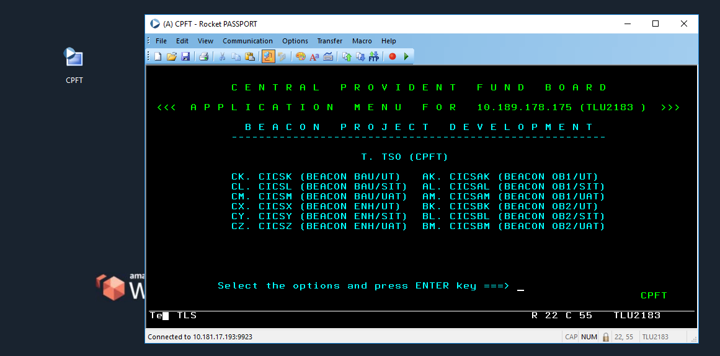

2.2 Login to TSO using your TSO account credentials.
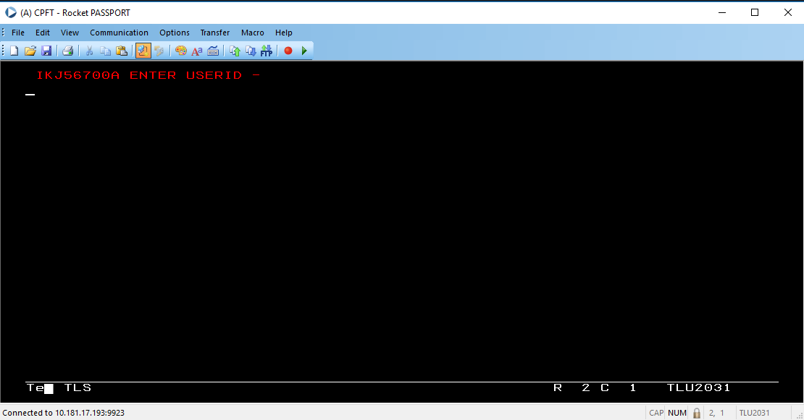
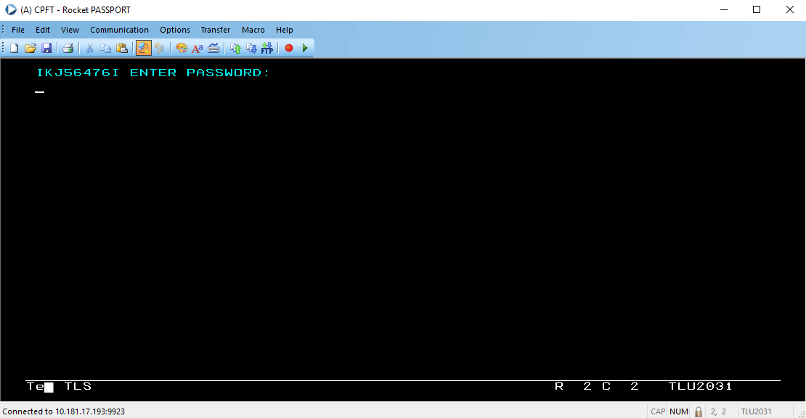

2.3 When you hit this menu, press Enter.
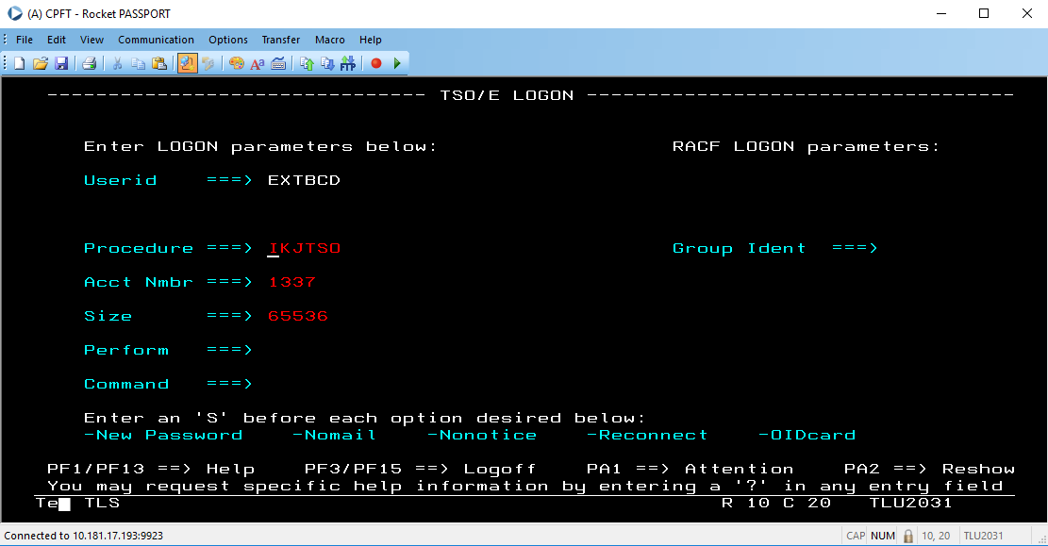

2.4 You will be redirected to this log menu. When you encounter these log messages, press Enter again.
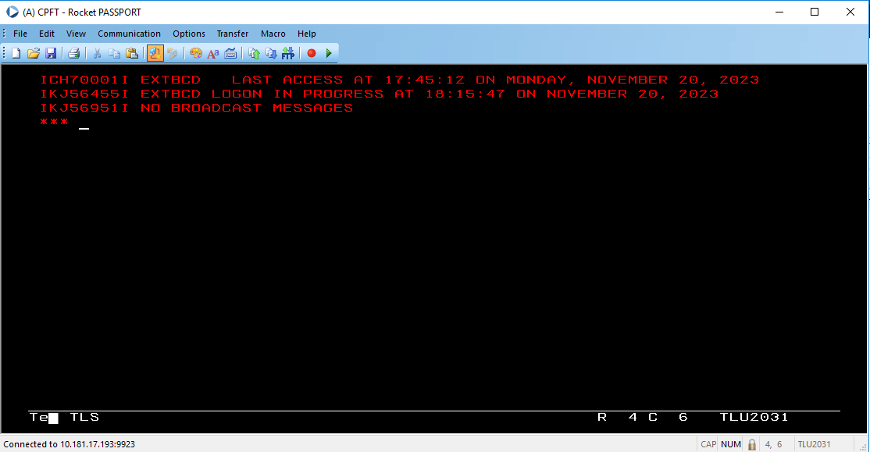
2.5 After being redirected to this menu, type in 3.4 beside the “option command” and press Enter.
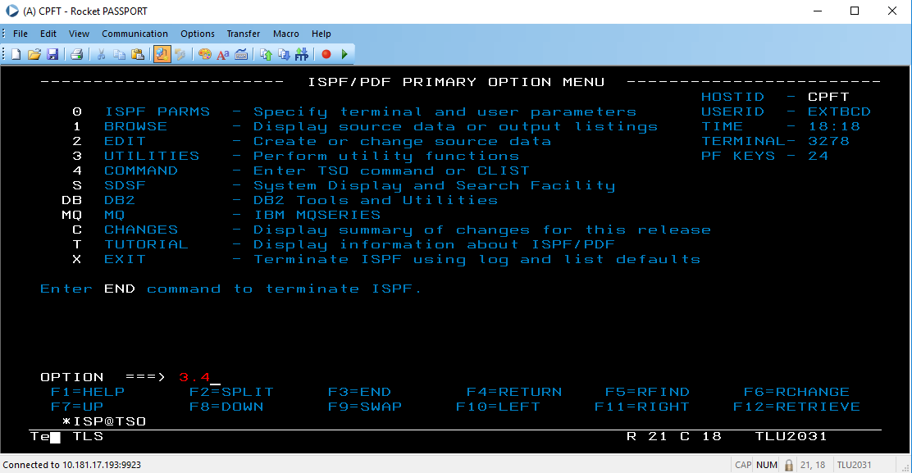

2.6 In this page, input your TSO ID in the Dsname Level and press Enter to access the folders inside the TSO ID you have specified.
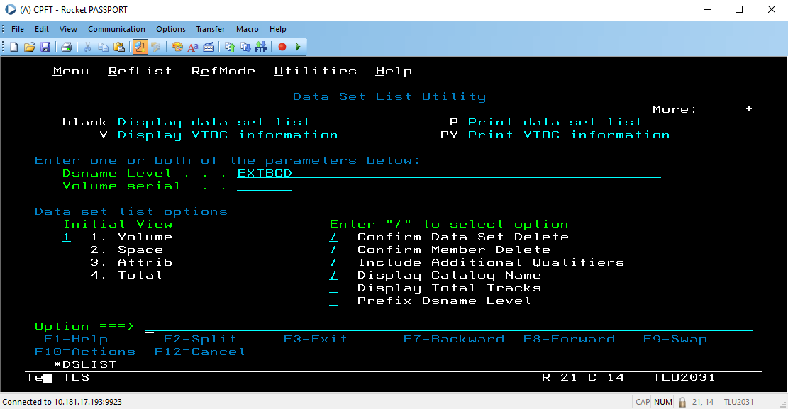
2.7 In this page you are now able to see and access your folders under this TSO ID.
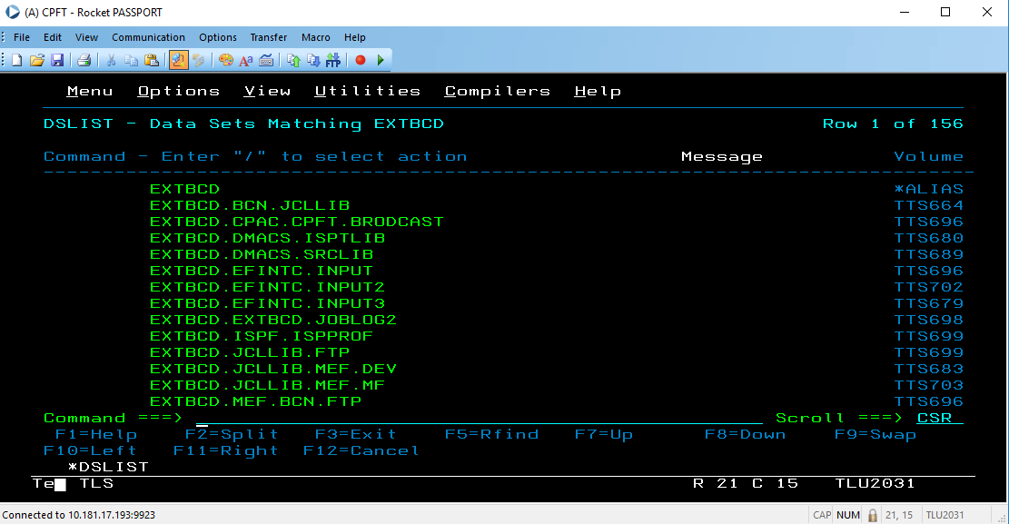

3. Creating your dataset
If you have existing dataset inside your TSO:
3.1 Go to the existing file, use the command / then press enter to show the options.
3.2 Input ‘17’ to copy and press Enter to go to Copy Entry Panel.
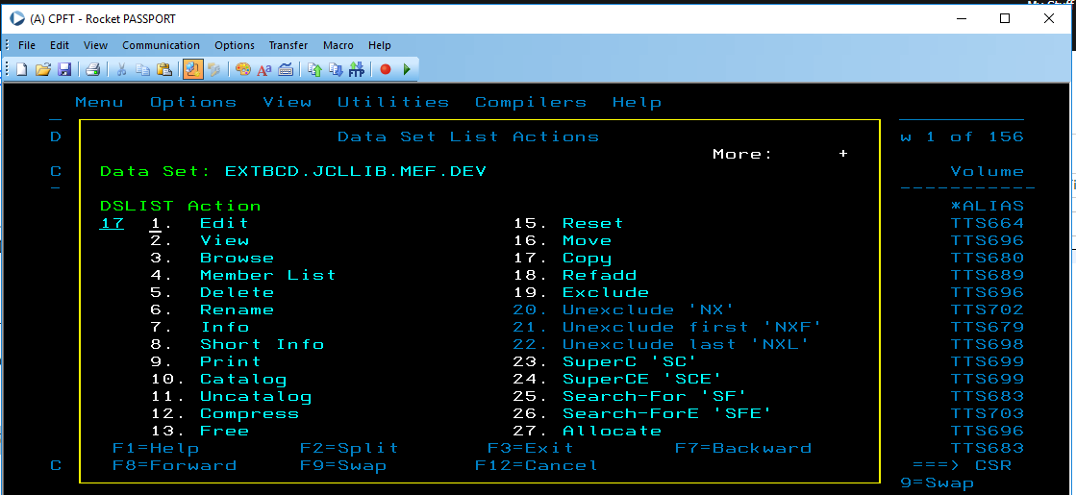
3.3 Input the name of your file in ‘Name’. Then press Enter. It should be different name from the file you are copying from.
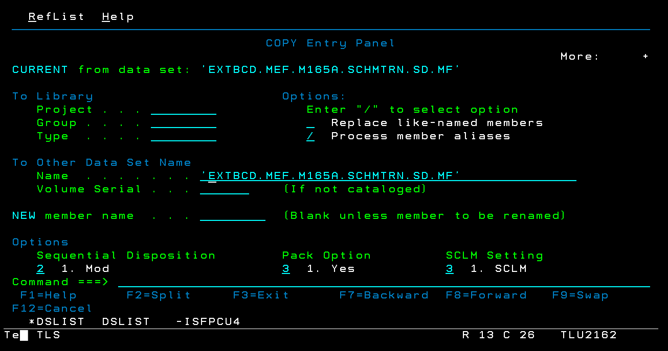

3.4 If you want to copy the same attributes, input 1. But if no, then input 2 to edit the allocation attributes.
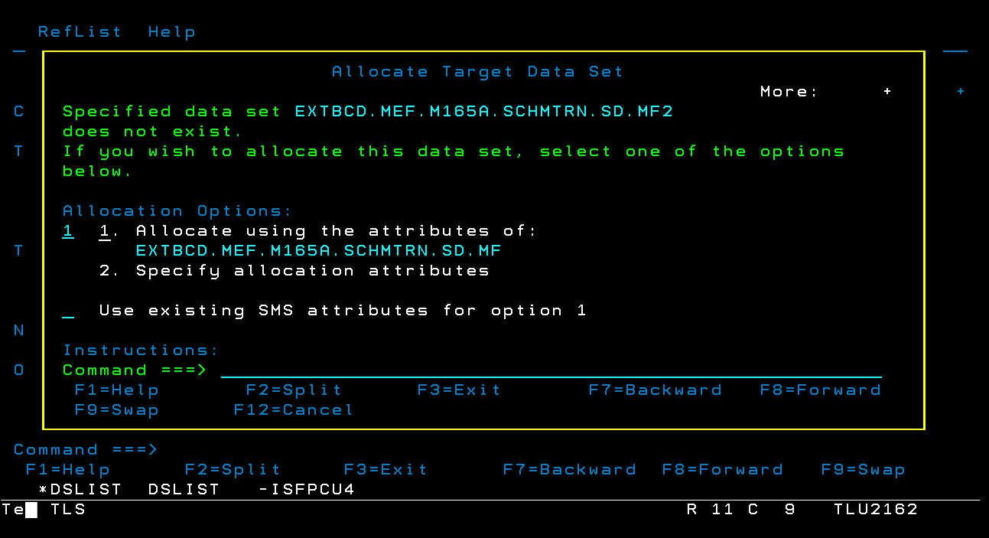
3.5 Configure the Record length based on the required length of your dataset. Block size should be empty.
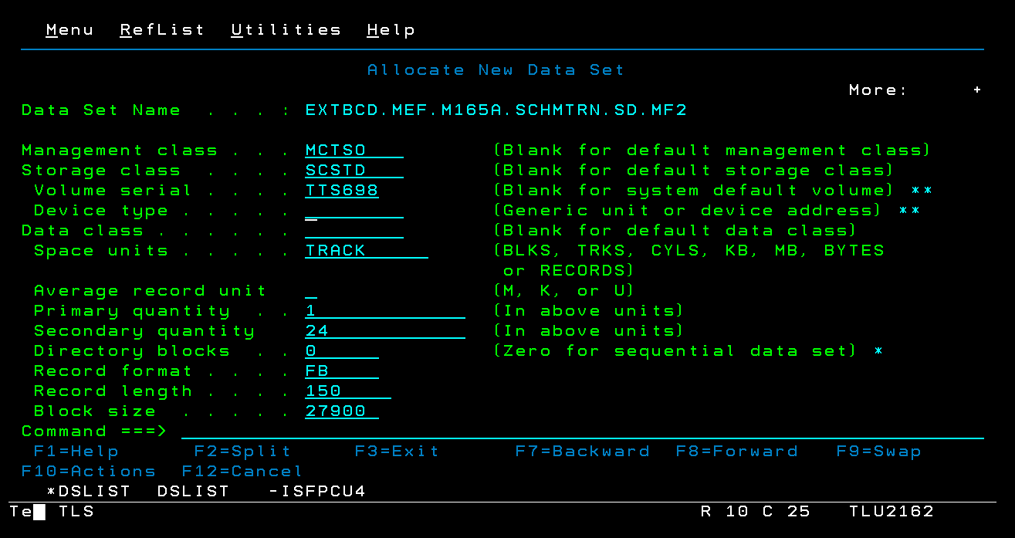

3.6 You will be redirected to this confirmation page. Press Enter to confirm.
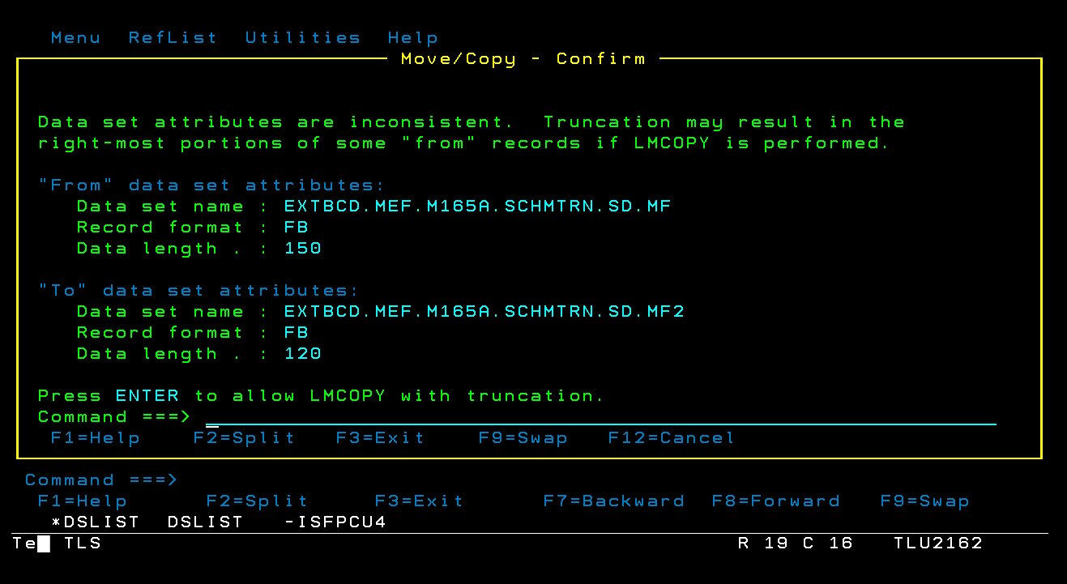
This will be the configuration of your new data set.

3.7 To edit the content of your new data set, use the ‘e’ command and press Enter.
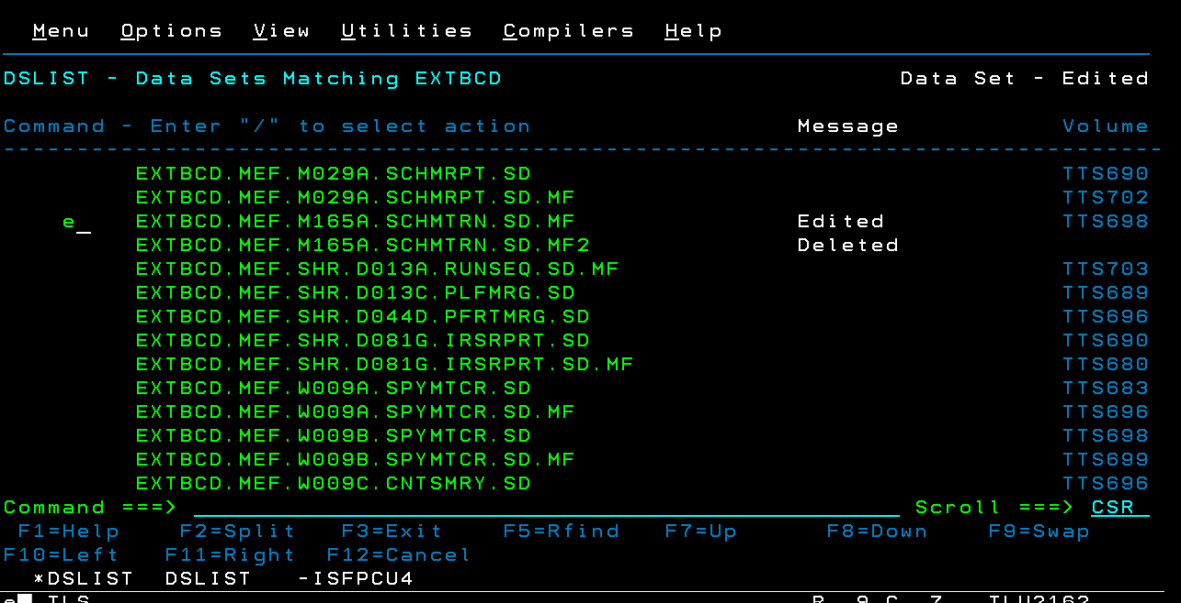

3.8 Input the data from your file layout and your data set should look like this.
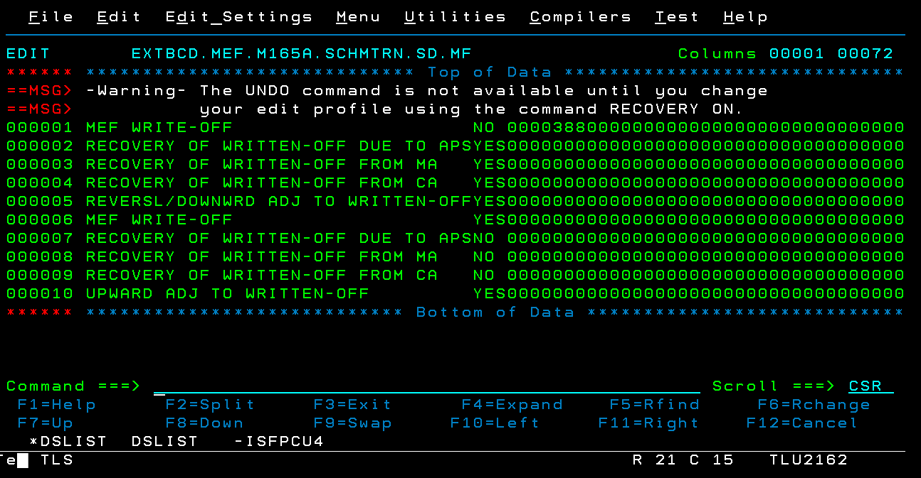

To create your dataset if there’s no existing files inside your TSO:

3.9 Once logged in inside TSO, Choose 3.2 from the options
3.10 Input the dataset name, then input ‘A’ in Option.

3.11 Input the desired record length, then Block size should be empty. Press Enter.
3.13 You can now see, access, and edit your dataset in your library.

